SNS COLLEGE OF TECHNOLOGY,COIMBATORE-641035

DEPARTMENT OF ELECTRONICS AND COMMUNICATION ENGINEERING

IOT ASSIGNMENT

TOPIC: Smart Waste Management System For Metropolitan Cities

NAME : Mohamad Ashansha A

ASSIGNMENT QUESTION:

**Build a python code, assume you get temperature and humidity values (generated with random function to a variable) and write a condition to continuously detect alarm in case of high temperature**

PYTHON CODE:

import random import time while(1!=0):

temperature = random.random() humidity = random.random()

#round(temperature,2) #round(humidity,2) ("print Temperature: ","%.5f" % temperature) print("Humidity: ","%.5f" % humidity) time.sleep(2)

if (temperature > 0.7): print("high temperature")

if ( humidity >0.7): print("high humidity")

print("")

EXECUTION RESULT

Program

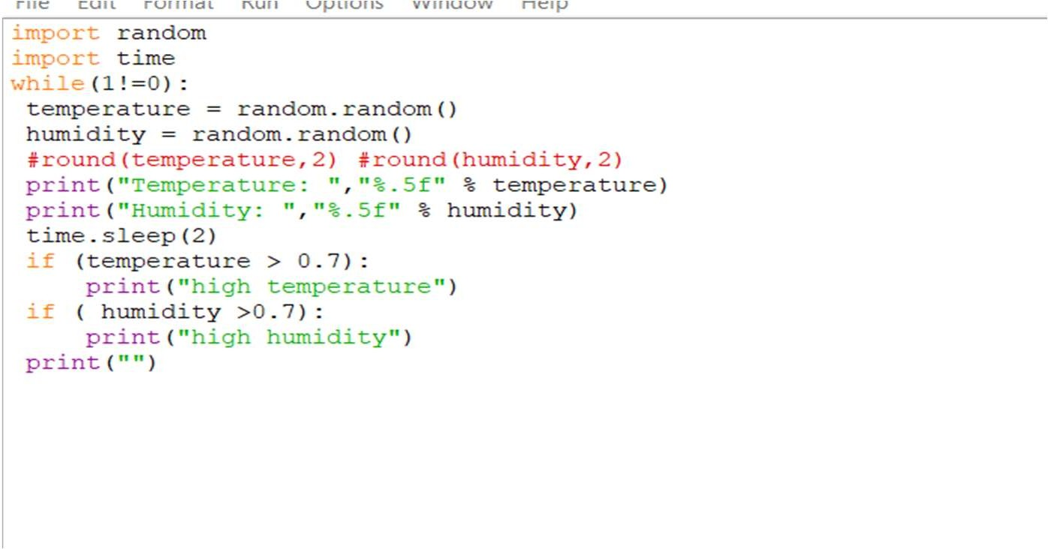

Output

